Modelling with MySQL Workbench. Data Types
- Conventions of ER Modelling (Workbench)
- Identifier or key:
- Fully identifies an instance完全标识一个实例
- Partial Identifier:
- Identifies an instance in conjunction with one or more partial identifiers
与一个或多个部分标识符一起标识一个实例
- Attributes types:
- Mandatory (blue diamond) 强制性的(蓝色钻石)
- Optional (empty diamond)
- Derived []导出
- [Age]
- Multivalued {}多值的
- {CarColour}
- Composite ()合成的
- Name (First, Middle, Last)
- Address (Street, Suburb, Postcode)
- Entity
- Attributes
- Unary relationships一元的关系
- Chen Notation (conceptual)
- Crows foot notation (logical and physical modelling)
- Binary relationships
- Chen Notation (conceptual)
- Crows foot notation (logical and physical modelling)
- Ternary relationships
- Chen Notation (conceptual)
- Crows foot notation (logical and physical modelling)
- Ternary relationships with attribute
- Chen Notation (conceptual)
- 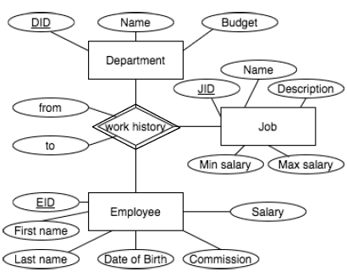
- Crows foot notation (logical and physical modelling)
- Conventions of ER Modelling ER建模的约定
- Cardinality Constraints基数限制
- Optional Many
- Partial participation
- Without key constraint
- 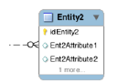
- Mandatory Many
- Total participation
- Without key constraint
- 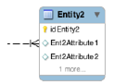
- Optional One
- Partial participation
- Key constraint
- 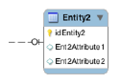
- Mandatory One
- Total participation
- Key constraint
- 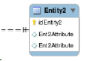
- Relationship Cardinality基数的关系
- One to One
- Each entity will have exactly 0 or 1 related entity
每个实体将恰好有0或1个相关实体
- One to Many
- One of the entities will have 0, 1 or more related entities, the other will have 0 or 1.
其中一个实体将有0、1或更多相关实体，另一个将有0或1。
- Many to Many
- Each of the entities will have 0, 1 or more related entities
- Conventions of ER Modelling ER建模的约定
- Strong Entity:
- Can exist by itself
- E.g. Customer Card, Customer
- Weak Entity
- Can’t exist without the owner
- E.g. BillDetaiLine
- Good / Bad Entity Selection
- Entity
- Will have many instances in the database数据库中会有很多实例吗
- Is composed of many attributes是由许多属性组成的吗
- Is something needed for the system to work (something we are trying to model) 系统工作所需要的东西(我们正在尝试建模的东西)
- Examples
- Person: EMPLOYEE, STUDENT, PATIENT
- Place: STORE, WAREHOUSE, STATE
- Object: MACHINE, BUILDING, VEHICLE
- Event: SALE, REGISTRATION, BROADCAST
- Concept: ACCOUNT, COURSE, ROLE
- An Entity IS NOT
- A user of the system
- An output of the system (i.e. a report)
- Single Entity Conceptual
- Chen
- Crows Foot
- Convert from Conceptual to Logical design (Single Entity)
从概念设计转换为逻辑设计(单实体)
- Tasks checklist:
- Convert composite and multi valued attributes转换复合属性和多值属性
- Multi Attribute values can become another table
多属性值可以成为另一个表
- Resolve many-many relationships
- Add foreign keys at crows foot end of relationships (on the many side)
- Convert the ER into a logical (rel.) model
- Customer=(
CustomerID,
CustFirstName, CustMiddleName,
CustLastName, BusinessName,
CustType, CustAddLine1,
CustAddLine2, CustSuburb,
CustPostcode, CustCountry)
- Convert from Logical to Physical Design
- Inputs
- Normalised relations
- Attribute definitions
- Response time expectations响应时间的期望
- Data security needs
- Backup / recovery needs
- Integrity expectations诚信的期望
- DBMS technology used
- Decisions
- Attribute data types
- Physical record descriptions物理记录的描述
- These don’t always match the logical design
这些并不总是与逻辑设计相匹配
- File organisations
- Indexes and database architectures索引和数据库体系结构
- Query optimisation查询优化
- Generate attribute data types
- Physical Design:
- Implementation:
- 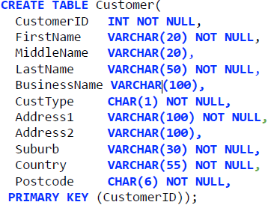
- More than One Entity
- A customer can have a number of Accounts
- The tables are linked through a foreign key
- 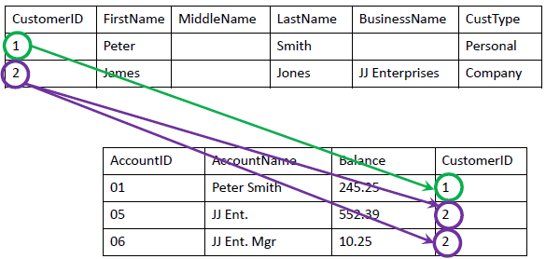
- Conceptual to Logical Design Account
- Conceptual Design:
- Tasks checklist
- Convert composite and multi valued attributes转换复合属性和多值属性
- Resolve many-many relationships
- Add foreign keys at crows foot end of relationships
- See FK1 CustomerID
- Every row in the account table must have a CustomerID from Customer (referential integrity)
帐户表中的每一行都必须具有来自Customer的CustomerID(参考完整性)
- Logical Design:
- Account=(
AccountID,
AccountName,
OutstandingBalance,
CustomerID)
- Design and Implementation-Account
- Physical design:
- Implementation:
- 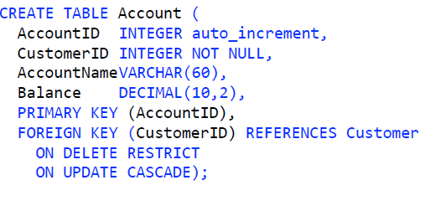
- Dealing with Multi-Valued Attributes
- Conceptual Design:
- Logical Design:
- Physical Design:
- Many to Many Relationship
- How to deal with employee jobs/positions…如何处理员工的工作/职位
- The fact is that employees change jobs within the company
事实上，员工会在公司内部换工作
- AND we probably need to store a history of jobs for employee
我们可能需要为员工存储工作的历史记录
- At the conceptual level it looks like this:
- 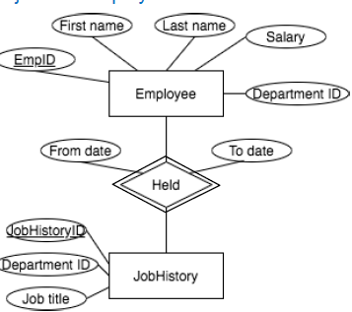
- Many to Many Logical Model
- 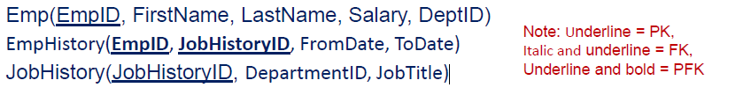
- 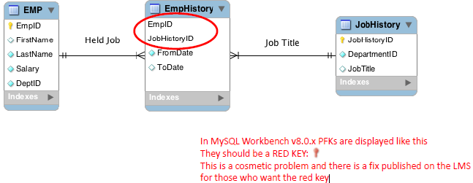
- When converting the conceptual to the logical diagram we create an Associative Entity between the other 2 entities
当将概念图转换为逻辑图时，我们在其他两个实体之间创建了一个关联实体
- Many to Many Physical Model and Implementation
- 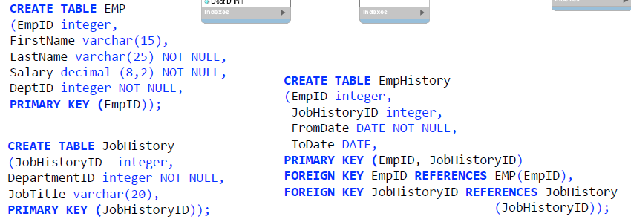
- One to One Relationship
- Rule: Move the key from the one side to the other side
- Need to decide whether to put the foreign key inside Nurse or CareCentre (in which case you would have the Date_Assigned in the same location)
需要决定是否将外键放在Nurse或CareCentre中(在这种情况下，您将在相同的位置有Date_Assigned)
- Where would the least NULL values be?
- The rule is the OPTIONAL side of the relationship gets the foreign key
- One to One Relationship-Logical and Physical Design
- Logical
- 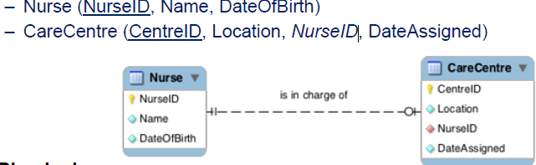
- Physical
- Summary of Binary Relationships
- One to Many
- Primary key on the one side becomes a foreign key on the many
一边的主键变成了另一边的外键
- Many to Many
- Create an Associative Entity (a new relation) with the primary keys of the two entities it relates to as the combined primary key
用它所关联的两个实体的主键作为组合主键创建一个关联实体(一个新的关系)
- One to One
- Need to decide where to put the foreign key
- The primary key on the mandatory side becomes a foreign key on the optional side强制端上的主键变成可选端上的外键
- If two optional or two mandatory, pick one arbitrarily
如果有两个可选的或两个必选的，任选一个
- Strong and Weak Entity Identifying Relationship
- How to map an Identifying relationship
- Map it the same way: Foreign Key goes into the relationship at the crow s foot end. 用同样的方式映射它:外键进入乌鸦脚末端的关系。
- Only Difference is: The Foreign Key becomes part of the Primary Key
- Logical Design
- 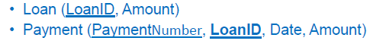
- Physical Design as per normal one to many
- Unary Relationships
- A unary relationship is when both participants in the relationship are the same entity 一元关系是指关系中的两个参与者是同一实体
- Operate in the same way as binary relationships与二进制关系的运作方式相同
- One to One
- Put a Foreign key in the relation在关系中放置一个外键
- One to Many
- Put a Foreign key in the relation
- Many to Many
- Generate an Associative Entity生成一个关联实体
- Put two Foreign keys in the Associative Entity
在关联实体中放入两个外键
- Need 2 different names for the Foreign keys
- Both Foreign keys become the combined key of the Associative Entity两个外键成为关联实体的组合键
- Unary: One to One
- Conceptual Design:
- Logical Design:
- Person (ID , Name, DateOfBirth, SpouseID)
- Physical Design:
- Implementation:
- 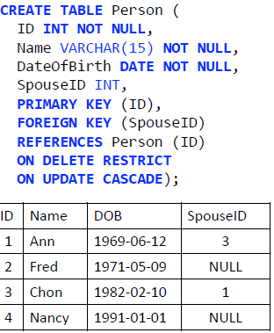
- Unary: One to Many
- Conceptual Design:
- Logical Design:
- Employee = (ID , Name, DateOfBirth, ManagerID)
- Physical Design:
- Implementation:
- 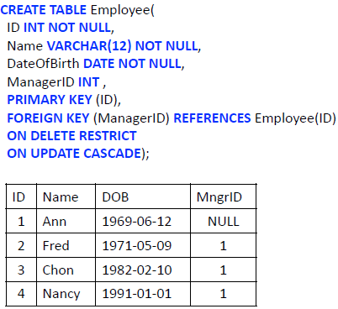
- Unary: Many to Many
- Conceptual Design:
- Logical Design:
- Create Associative Entity like usual
- Generate logical model
- 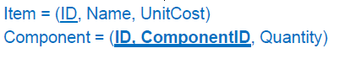
- Unary: Many to Many Implementation
- 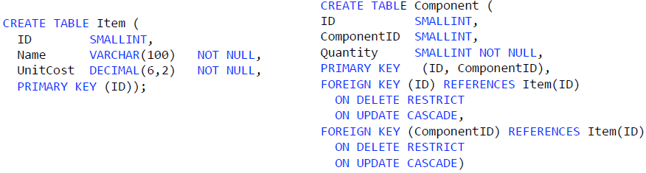
- Ternary relationships
- Relationships between three entities
- Logical Design:
- Generate an Associative Entity
- Three One to Many relationships
- Same rules then apply as One to Many
- 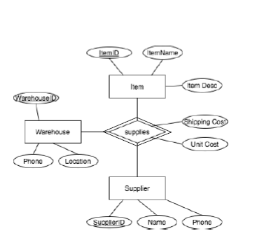
- Conceptual Model Mapping
- 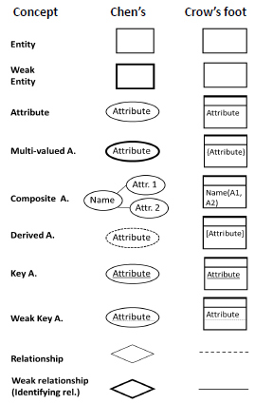
- 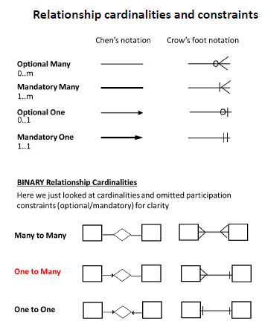
- Conceptual to Physical checklist
- 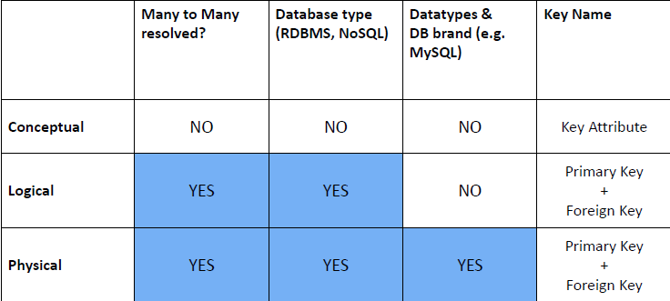
- MySQL Data Types
- Choosing data types
- Column: smallest unit of data in database列:数据库中数据的最小单位
- Data types help DBMS to store and use information efficiently
数据类型帮助DBMS有效地存储和使用信息
- You should choose data types that:
- enforce data integrity (quality) 执行数据完整性(质量)
- can represent all possible values
- support all required data manipulations支持所有需要的数据操作
- minimize storage space减少存储空间
- maximize performance ( e.g. fixed or variable length)
- The major data types categories are:
- Text/string or character
- Number
- Integer
- Decimal
- Float, Double
- Date and time
- Character types (MySQL)
- CHAR (M): A fixed length string that is always right padded with spaces to the specified length when stored on disc.
一个固定长度的字符串，当存储在磁盘上时，它总是用空格填充到指定的长度。
- The range of M is 1 to 255.
- CHAR: Synonym for CHAR(1).
- VARCHAR (M): A variable length string. Only the characters inserted are stored no padding. 可变长度字符串。只有插入的字符被存储，没有填充。
- The range of M is 1 to 65535 characters.
- BLOB, TEXT: A binary or text object with a maximum length of 65535 (2^16) bytes (blob) or characters (text).
BLOB, TEXT:一个最大长度为65535(2^16)字节(BLOB)或字符(TEXT)的二进制或文本对象。
- Not stored inline with row data. 未与行数据内联存储。
- LONGBLOB, LONGTEXT: A BLOB or TEXT column with a maximum length of 4,294,967,295 (2^32 1) characters.
LONGBLOB, LONGTEXT:最大长度为4,294,967,295(2^32 1)个字符的BLOB或TEXT列。
- ENUM (‘value1’,’value2’,…) up to 65,535
- Number types (MySQL)
- Integers
- TINYINT: Signed ( 128 to 127), Unsigned (0 to 255)
- BIT, BOOL: synonyms 同义词for TINYINT
- SMALLINT: Signed ( 32,768 to 32,767), Unsigned (0 to 65,535 2^16 or 64k)
- MEDIUMINT: Signed ( 8388608 to 8388607), Unsigned (0 to 16777215 16M)
- INT / INTEGER: Signed (2,147,483,648 to 2,147,483,647), Unsigned (0 to 4,294,967,295 2^32 or 4G)
- BIGINT: Signed (9223372036854775808 to 9223372036854775807), Unsigned (0 to 18,446,744,073,709,551,615 2^64)
- Don’t use the “(M)” number for integers
- Real numbers (fractions)
- FLOAT: single precision floating point, allowable values: 3.402823466E+38 to 1.175494351E 38, 0, and 1.175494351E 38 to 3.402823466E+38.
- DOUBLE / REAL: double precision, allowable values双精度，允许值: 1.7976931348623157E+308 to 2.2250738585072014E 308, 0, and 2.2250738585072014E 308 to 1.7976931348623157E+308.
- optional M = number of digits stored, D = number of decimals.
可选的M =存储的位数，D =小数点。
- Float and Double are often used for scientific data.
- DECIMAL [(M[,D])]: fixed point type. Good for money values.
- M = precision (total number of digits stored) 精度(存储的总位数), D = number of decimals (within M)
- Date Time types
- DATE
- used for values with a date part but no time part.
用于具有日期部分但没有时间部分的值。
- MySQL retrieves and displays DATE values in 'YYYY MM DD' format; 1000-01-01 to 9999-12-31
- TIME
- retrieves and displays TIME values in ' hh:mm:ss ' format; 838:59:59 to 838:59:59 (time of day or elapsed time)
- DATETIME
- used for values that contain both date and time parts.
- MySQL retrieves and displays DATETIME values in 'YYYY-MM-DD hh:mm:ss ' format;
- 1000-01-01 00:00:00 to 9999-12-31 23:59:59
- Stored in local time
- TIMESTAMP
- 1970-01-01 00:00:00 --'2038-01-19 03:14:07'
- used for values that contain both date and time parts
用于同时包含日期和时间部分的值
- Stored in UTC, converted to local when retrieved, which allows to use a different time zone when you connect to MySQL Server.
存储在UTC，检索时转换为本地，这允许使用不同的时区时，你连接到MySQL服务器。
- YEAR
- 1901 to 2155

Normalisation规范化
- Anomalies in Denormalised Data非规格化数据中的异常
- Consider the following denormalised table (relation) :
- 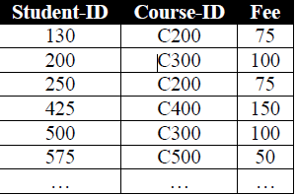
- Insertion Anomaly: A new course cannot be added until at least one student has enrolled (which comes first student or course?)
插入异常:新课程不能添加，直到至少有一个学生注册(哪个是第一个学生还是第一个课程?)
- An insertion anomaly is the inability to add certain attributes to a database due to absence of other attributes.
插入异常是由于缺少其他属性而无法向数据库添加某些属性。
- Deletion Anomaly: If student 425 withdraws, we lose all record of course C400 and its fee!
删除异常:如果学生425退出，我们将丢失所有C400课程记录和费用!
- A deletion anomaly is an unintentional loss of certain attribute values due to the deletion of other data for other attributes.
删除异常是由于其他属性的其他数据被删除而导致某些属性值无意丢失。
- Update Anomaly: If the fee for course C200 changes, we have to change it in multiple records (rows), else the data will be inconsistent.
Update Anomaly:如果C200课程的费用发生变化，我们必须在多个记录(行)中进行更改，否则数据将不一致。
- An update anomaly is a data inconsistency that results from data redundancy and partial update when one or more instances of duplicated data are updated but not all.
更新异常是指当重复数据的一个或多个实例被更新而不是全部时，数据冗余和部分更新导致的数据不一致。
- Normalisation
- A technique used to remove undesired redundancy from databases (Break one large table into several smaller tables).
一种用于从数据库中删除不需要的冗余的技术(将一个大表拆分成几个小表)。
- A relation is normalised if all determinants are candidate keys
如果所有行列式都是候选键，则关系被规范化
- Normalised Relations and ER Diagram
- We can name the relations now
- 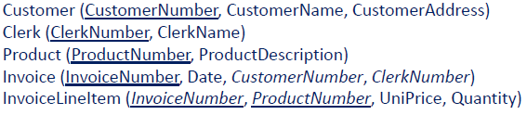
- Normalisation and Associated Concepts标准化和相关概念
- Functional Dependency函数相关性
- A functional dependency concerns values of attributes in a relation
函数依赖关系关注关系中属性的值
- The attribute Y is fully functionally dependent on the attribute X if each value of X determines one and only value of Y
属性Y在功能上完全依赖于属性X，如果X的每个值决定了Y的一个且唯一的值
- Notation: X → Y
- X determines Y (If I know X then I also know Y)
- Determinants (X,Y →Z)
- the attribute(s) on the left hand side of the arrow箭头左边的属性
- Key and Non-Key attributes
- each attribute is either part of the primary key or it is not
每个属性要么是主键的一部分，要么不是
- Partial functional dependency (Y →Z)
- a functional dependency of one or more non key attributes upon part (but not all) of the primary key,
一个或多个非键属性对部分(而不是全部)主键的函数依赖性
- e.g. (StudentID , SubjectCode ) --> StudentName
- Transitive dependency (Z →D) 传递相关性
- a functional dependency between 2 (or more) non key attributes,
两个(或更多)非键属性之间的函数依赖关系
- e.g. SubjCode|SubjectName|LecturerID|LecturerName results in SubjCode -->LecturerName
- Armstrong’s Axioms阿姆斯特朗的公理
- Functional dependencies can be identified using Armstrong’s Axioms
- 𝐴 = 𝑋1, 𝑋2, … , 𝑋𝑛 𝑎𝑛𝑑 𝐵 = (𝑌1, 𝑌2, … , 𝑌𝑛)
- Reflexivity反射性: 𝐵 ⊆ 𝐴 ⟹ 𝐴 → 𝐵
- Example: Student_ID, name -> name
- Augmentation: 𝐴 → 𝐵 ⟹ AC → 𝐵𝐶
- Example: Student_ID -> name => Student_ID, surname ->name, surname
- Transitivity: 𝐴 → 𝐵 and B → 𝐶 ⟹ 𝐴 → 𝐶
- Example: ID -> birthdate, and birthdate -> age then ID ->age
- Steps in Normalisation
- Normal form-the state of a relation resulting from applying rules about the functional dependency of some attributes upon others
正常形式——由于应用了一些属性对其他属性的函数依赖性的规则而产生的关系状态
- First Normal Form: Keep atomic data/Remove repeating groups
保持原子数据/删除重复组
- Second Normal Form: Remove partial dependencies
- Third Normal Form: Remove transitive dependencies删除传递依赖关系
- Example: UNF (unnormalised form)
- 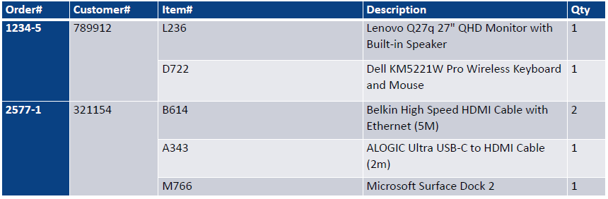
- First Normal Form (1NF)
- repeating groups of attributes cannot be represented in a flat, two dimensional table重复的属性组不能在平面的二维表中表示
- removing cells with multiple values (keep atomic data)
删除具有多个值的单元格(保留原子数据)
- eliminate nulls
- 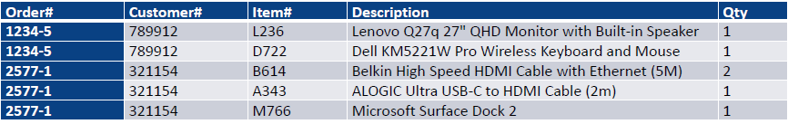
- Identify PK
- Identify all dependencies
- The obvious dependency:
- 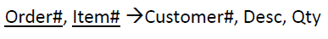
- Additional dependencies:
- 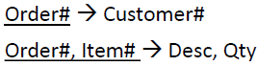
- Partial dependency:
- 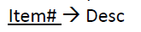
- First Normal Form Dependency Diagram第一个标准形式依赖关系图
- 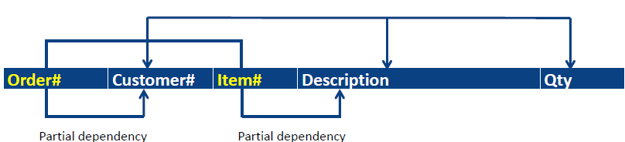
- The arrows above the attributes indicate all desirable dependencies, i.e. dependencies based on PK Order# and Item#
属性上面的箭头表示所有需要的依赖关系，即基于PK Order#和Item#的依赖关系
- The arrows below the attributes indicate partial dependencies
属性下面的箭头表示部分依赖关系
- Partial Dependency Anomalies部分依赖异常
- 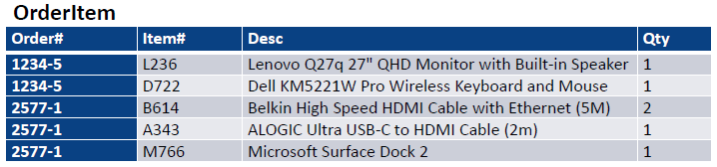
- UPDATE: change item desc in many places
- DELETE: data for last item lost when last order for that item is deleted
当最后一个项目的订单被删除时，该项目的数据丢失
- INSERT: cannot add new item until it is ordered
在订购之前，无法添加新项目
- Second Normal Form (2NF)
- 2NF occurs only when the 1NF has a composite PK
2NF只在1NF具有复合PK时才会发生
- If a table has a single attribute PK, it’s already in 2NF
如果一个表只有一个属性PK，那么它已经在2NF中了
- Eliminate Partial Dependencies-create new tables
- 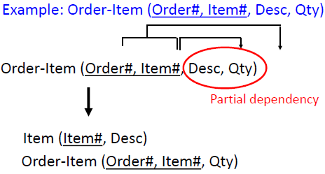
- 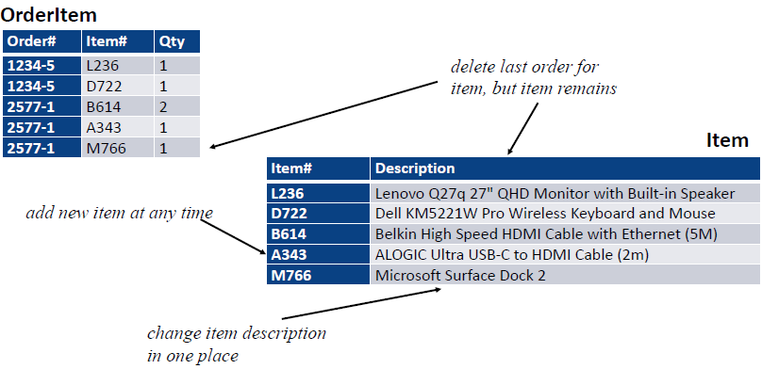
- Third Normal Form
- Eliminate Transitive Dependencies
- a non-key attribute cannot be identified by another non key attribute
一个非键属性不能被另一个非键属性识别
- 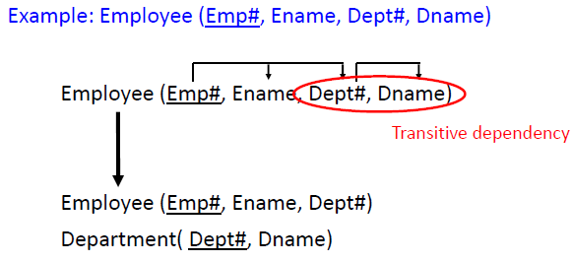
- Transitive Dependency Anomalies传递依赖异常
- 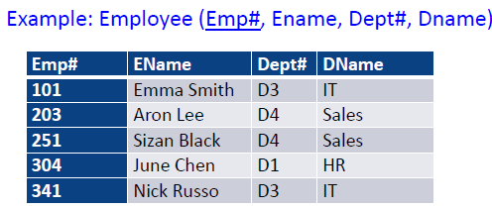
- UPDATE: change dept name in many places
- DELETE: data for dept lost when last employee for that dept is deleted当该部门的最后一个员工被删除时，该部门的数据丢失
- INSERT: cannot add new dept until an employee is allocated to it
- 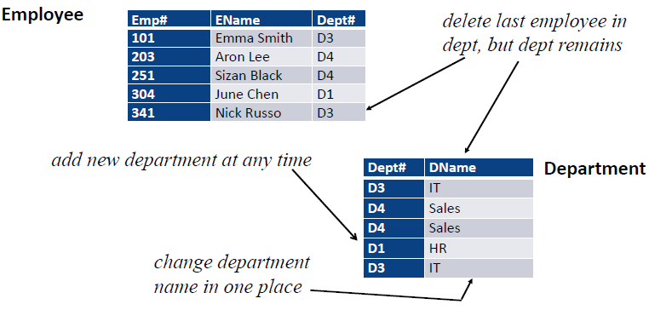
- Boyce-Codd Normal Form正规化型式
- Every determinant must be a candidate key每个行列式必须是一个候选键
- "Every non-key attribute must provide a fact about the key, the whole key, and nothing but the key. (So help me Codd)”
“每个非键属性必须提供一个关于键、整个键的事实，而且除了键什么都没有。(拜托，科德)”
- 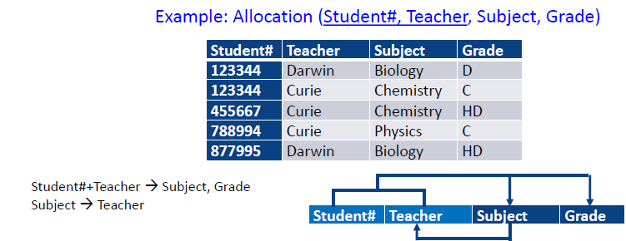
- Boyce-Codd Anomalies
- 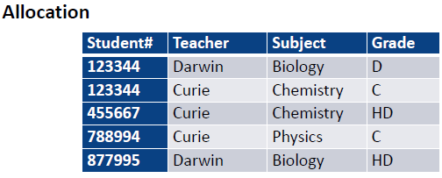
- UPDATE: student changing subject may lose teacher for that subject
- DELETE: deleting student may lose subject allocated to that teacher
- CREATE: cannot assign a subject to a teacher until a student takes it
- 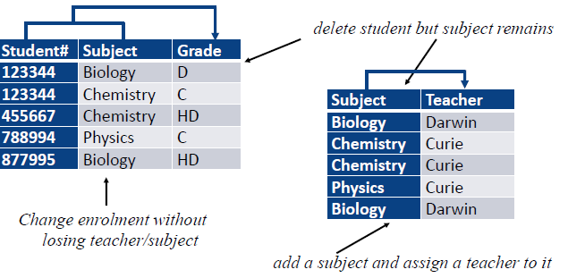
- Boyce-Codd is taught for completeness but is not examinable
博伊斯-科德的教学是为了完整性，但不是可检验的

